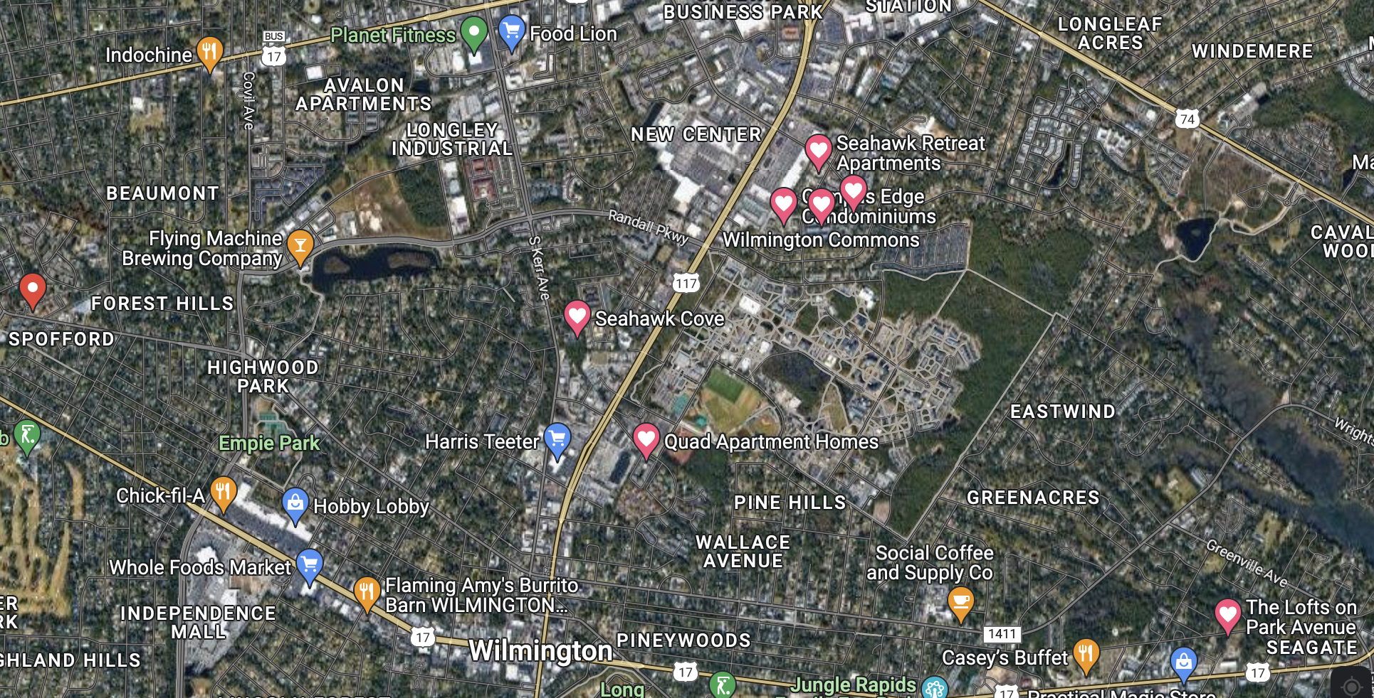

The hearted Places/red flagged place are apartments where we could put buttons

